MAT1033 Final Exam Name: _______________________________
Form B
Directions: Show all necessary steps leading to the answers in the space provided. For each question, a correct answer is only worth 1 point.
SHORT ANSWER. Write the word or phrase that best completes each statement or answers the question.
- Solve and graph. Write the result in interval notation.
6x ≤60
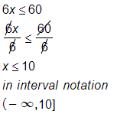
- Solve the system by the addition method.
4x + 9y = -15
-5x - 4y = 26
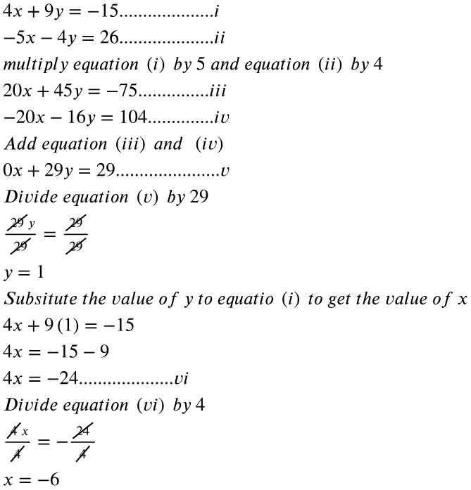
- Divide the rational expressions.
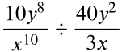
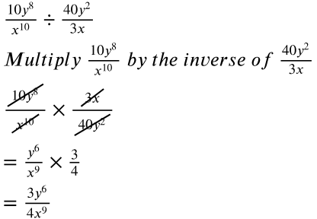

- Multiply the radical expressions and simplify your answer.
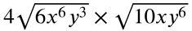
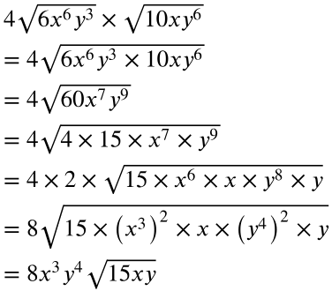
Perform the indicated operations. Simplify the result, if possible. Show all your work.
- 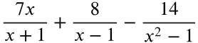
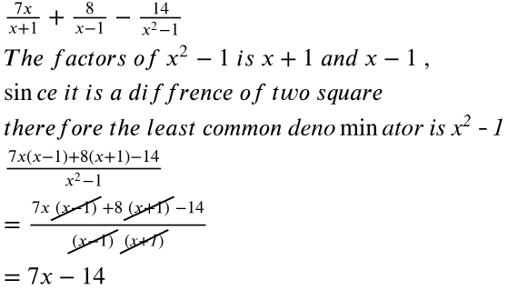

SHORT ANSWER. Find the least common denominator of the rational expressions.
- 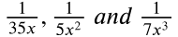
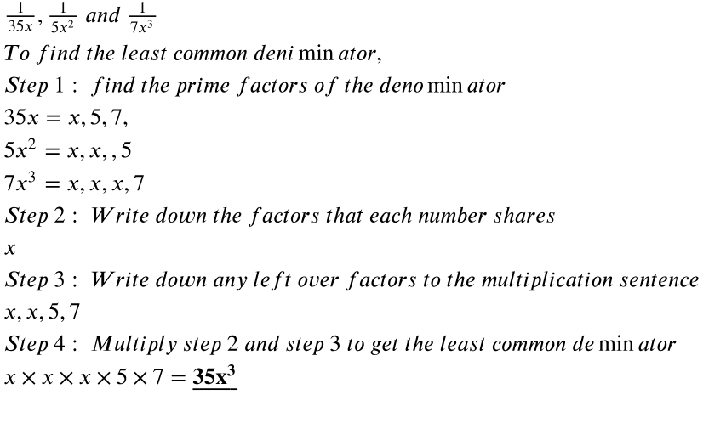
- Solve the equation
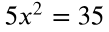
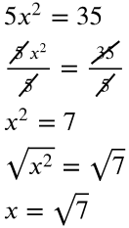
- Simplify the rational expression. List any restrictions.
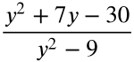
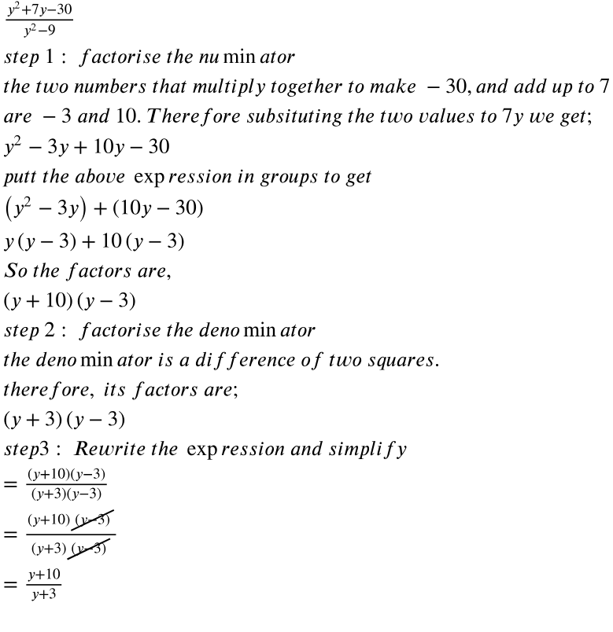

- Write an equation of the line satisfying the given conditions. Write the answer in slope-intercept form. The line passes through (2, 10) and (3, 12).
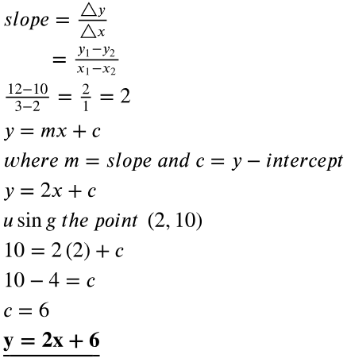
MULTIPLE CHOICE. Choose the one alternative that best completes the statement or answers the question.
- Which one of the following methods cannot be used to solve the equation x2 - 4x - 6 = 0?
A) Completing the square B) Factoring
C) Quadratic formula D) All of the methods can be used.
SHORT ANSWER. Write the word or phrase that best completes each statement or answers the question.
- Express in terms of i.
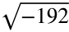
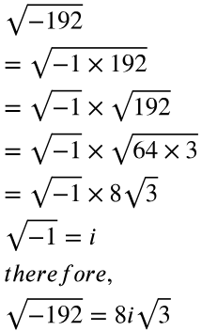
Find the slope of the line containing the two given points.
- (-4, 10) and (13, -14)
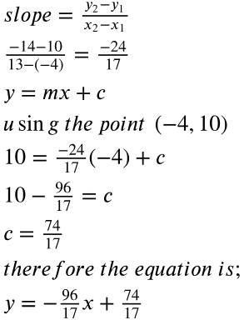
- Express the compound inequality using interval notation, and graph the solution set.
x < - 4 or x > 7
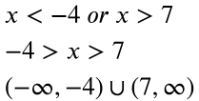
14) Solve using the quadratic formula. Show all your work.
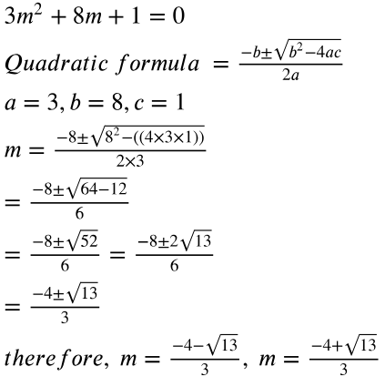

SHORT ANSWER. Write the word or phrase that best completes each statement or answers the question.
- Solve and graph.
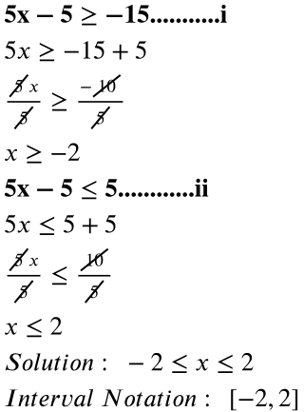

- Add the radical expressions.
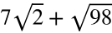
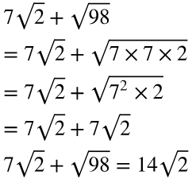
- Simplify the expression. Assume that all variables represent positive real numbers.
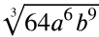
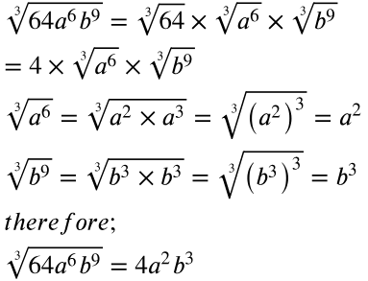
- Solve the equation.
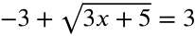
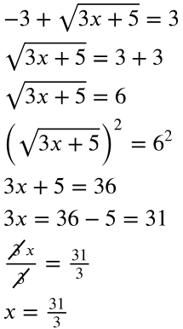
- Write an equation of the line satisfying the given conditions. Write the answer in slope-intercept form. The line passes through the point (2, 15) and has a slope of 5.
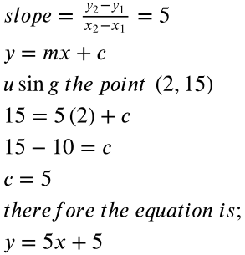
- Determine the slope and the y-intercept.
6x - 9y = -27
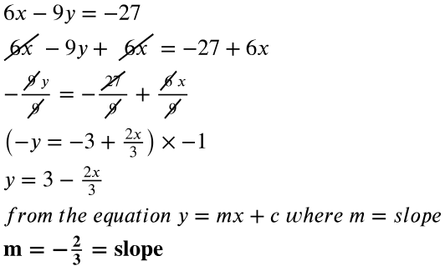
- Graph: y < -4
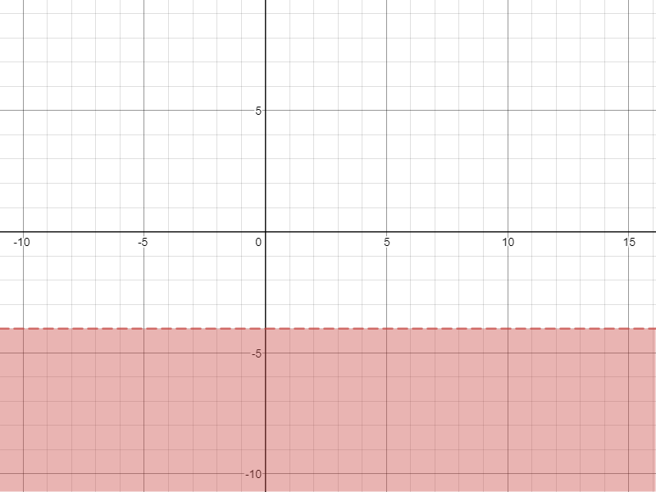
- Simplify using the division property of radicals. Assume that all variables represent positive real numbers.
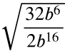
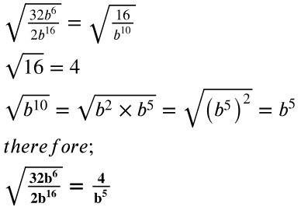
- Solve the equation. Show all your work.
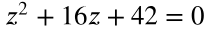
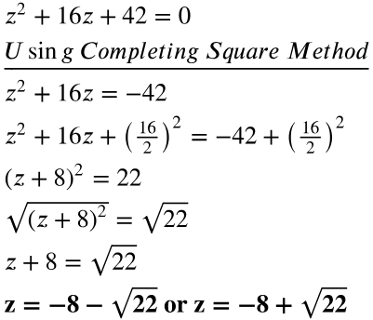
SHORT ANSWER. Write the word or phrase that best completes each statement or answers the question.
- Solve the system by using the substitution method.
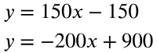
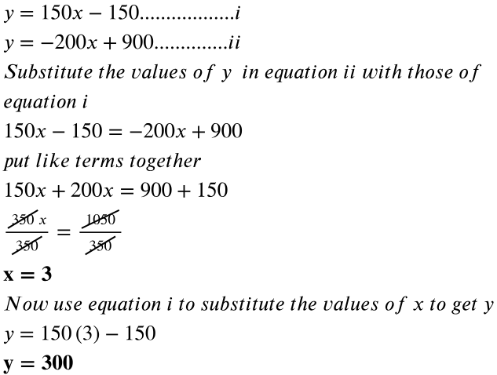
- Convert the expression to radical form and simplify
